Ministries that Christ First Christian Church supports …

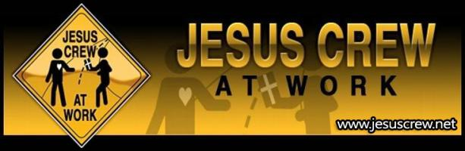
Jesus Crew Street Ministries is a ministry devoted to spreading the gospel of salvation through repentance and faith in Jesus Christ. We proclaim the truth through gospel tracts, one to one witnessing and open air preaching. Jesus Crew encourages Christians to read their bibles so that they will be equipped to evangelize. You can read every book written by Christian authors but if you do not read the book that was written by the Holy Spirit then you will not have the truth that the lost world needs. We hope to provide encouragement and resources to Christians to do the work of an evangelist to preach the Word in season and out. Check out the Jesus Crew teams that we have and see if there is one near you. Jose & Amy Muniz founded the Jesus Crew Street Ministries in Rule, Texas in 1984 and have been preaching the gospel faithfully for over 33 years. We at JesusCrew also have 42 evangelism teams in 9 different countries in Africa, including Kenya, Uganda, South Sudan, Tanzania, Rwanda, South Africa, Burundi, Zambia and The Congo. We have JesusCrew Orphanage and Golden Life High School! All made possible by God! Go to the JesusCrew News page for video.
http://www.jesuscrew.net/
+++++++++++++++++++++++
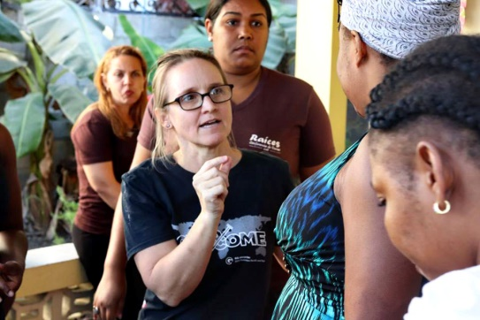
When people ask what I do - I sometimes say - I find the Bathshebas and Ruths and Rahab's of this world - and put them in ministry. We restore and empower the disenfranchised and the powerless. We give them voice, we show them who they are created to be, we heal and help them live out their life as God intended - which is often fighting for more women - the abused, the trafficked, the forgotten.
julie.e.wiegand@gmail.com
+++++++++++++++++++++++++++++++++++++++

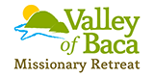
The Valley of Baca exists to provide support to missionaries from the Christian Churches, and Churches of Christ around the world during their time in the United States.

